A
Project Report
on
SWP-COVID19

Submitted to

CHHATTISGARH SWAMI VIVEKANAND TECHNICAL UNIVERSITY, BHILAI

in partial fulfillment
for the award of the degree
of
Bachelor of Engineering
in
Computer Science and Engineering
by

Animesh Kumar Shukla
(301302217013)


Department of Computer Science and Engineering,
Rungta College of Engineering and Technology,
Kohka, Kurud Road, Bhilai , Chhattisgarh 490024

Session: 2020-2021

DECLARATION BY THE CANDIDATE

I/We the undersigned solemnly declare that the report of the project work entitled “SWP – COVID19”, is based on our own work.

I/We assert that the statements made and conclusions drawn are an outcome of the project work. I/We further declare that to the best of our knowledge and belief that the report does not contain any part of any work which has been submitted for the award of any other degree/diploma/certificate in this University/ any other University of India or any other country.

_________________

ANIMESH KUMAR SHUKLA
Roll No.: 301302217013
Enrollment No.: BD4836
CERTIFICATE

This is to Certify that the report of the project submitted is an outcome of the project work entitled SWP – COVID19 carried out by team:

- Animesh Kumar Shukla - 301302217013 / BD4836

- Jasleen Kaur – 301302217049 / BD3256

- Nilesh Madharia – 301302217075 / BD3347

under guidance and supervision for the award of Degree in Bachelor of Engineering in Computer Science & Engineering from Chhattisgarh Swami Vivekananda Technical University, Bhilai (C.G).

To the best of our knowledge the report
- Embodies the work of the candidate himself / herself,
- Has duly been completed,
- Fulfills the requirement of the Ordinance relating to the BE degree of the University,
- Is up to the desired standard for the purpose of which is submitted.

Guide
Prof. Neelabh Sao
Department of Computer Science & Engineering

The project work as mentioned above is hereby being recommended and forwarded for examination and evaluation.

(Prof. K. J. Satao)
Head of the Department
Department of Computer Sc. & Engineering

CERTIFICATE BY THE EXAMINERS

This is to Certify that the project the entitled “SWP – COVID19”
Submitted by -

Student Name : Animesh Kumar Shukla
Enrollment No: BD4836
Roll No: 301302217013

Student Name: Jasleen Kaur
Enrollment No: BD3256
Roll No: 301302217049

Student Name: Nilesh Madharia
Enrollment No: BD3347
Roll No: 301302217075
Have been examined by the undersigned as a part of the examination for the award of Bachelor of Engineering degree in Computer Science and Engineering from Chhattisgarh Swami Vivekanand Technical University, Bhilai (C.G)

(Internal Examiner) (External Examiner)
Name : Prof. Ajay Kushwaha Name:
Date : 17-06-2021 Date:

ACKNOWLEDGEMENT

I have great pleasure in the submission of this project report entitled SWP-COVID19 (Society Welfare Portal For COVID-19) in partial fulfillment the degree of Bachelor of Engineering (CSE). While submitting this Project report, I take this opportunity to thank those directly or indirectly related to project work.

I would like to thank my guide Prof. Neelabh Sao who has provided the opportunity and organizing project for me. Without his active cooperation and guidance, it would have become very difficult to complete task in time.

I would like to express sincere thanks and gratitude to, Prof. K. J. Satao (Head of the Department) Computer Science & Engineering for their encouragement and cordial support. I also acknowledge with deep sense of responsibility and gratitude, the support given by respected Prof. Shrikant Burje (Vice Principal) and respected Dr. Mohan Awasthy, (Principal), Rungta College of Engineering and Technology, Bhilai.

I also like to thank many people in our college, faculty members of Computer Science and Engineering Department and supporting staff, for always being helpful over the years.

My special thanks are to respected Dr. Sourabh Rungta Sir for infusing his endless enthusiasm into all of us and instilling a spirit of dynamism in us.

INDEX

- About Project

- Objective
- Introduction
- Key features

- Description

    - PHP
    - MySQL
    - HTML
    - CSS
    - AngularJS
    - Bootstrap

- Hardware Requirements

- Software Requirements

- Flow diagram

      - Working
      - Technology Stack

- Outputs

- Snippets

- Conclusion

- Future scope

- Bibliography

ABOUT THE PROJECT…

OBJECTIVE: -

The lack of transparency in COVID-19 pandemic situation is being considered as boon by the fraudsters and the black marketers. The people are out to help but are unable to reach the needy. The main Objective of SWP-COVID19 is to develop an e-enabled design to make a direct connection between the needy and the helping hand contributors.

INTRODUCTION: -

SWP-COVID19 which stands for Society Welfare Portal For COVID-19 is India’s
Peer-to-peer resource sharing platform. It was started in April 2020 during the on-set of the COVID-19 lockdown. It brings the concept of helping your neighborhood at a time of need – to virtual space. The users can connect with each other in their community by placing requests for essential resources.

KEY FEATURES: -

- Flexible:

The design should enable future requirements of the business to be incorporated without too much difficulty. Often during the analysis phase, users may not be clear about exactly what they will require from the new system, for example which reports will be most useful to them. However during the evaluation period after the new system becomes operational, the real needs often emerge and flexible design will be able to accommodate these new requirements .In addition, business change over time and a good design enable the system to reflect these changes.

- Maintainable:

This is closely linked to the previous objective because it is about change. A good design is easy to maintain and this reduces the client’s maintenance costs, which usually represent a high proportion of the total lifetime cost of the system.

- No third-party involvement:

SWP-COVID19 provides a service where the people will directly connect with other without any involvement of the third part (except government).

- Secure:

Security is neither objective that must be considered by the designer. In order to protect the confidentiality of the data, particularly if it is commercially sensitive, it may be important to build in methods to restrict access to authorized users only, for example by introducing passwords.

- Absolutely free service to:

The user will not be charged with any amount.

- Reliable:

The portal will only contain the resources such as hospital beds, medicines , oxygen cylinders etc from reliable sources.

DESCRIPTION

The project (SWP -COVID19) is developed by using the following languages: -

PHP:
- PHP is a widely-used, open-source scripting language
- PHP scripts are executed on the server
- PHP is free to download and use
- That is especially suited for web development and an HTML-embedded scripting language
- The goal of the language is to allow web developers to write dynamically generated pages quickly
- Much of its syntax is borrowed from C, Java and Perl with a couple of unique PHP-specific features thrown in.

MySQL :

- MYSQL is a high performance, relational database server based on MYSQL.
- It is built on CLIENT/SERVER architecture, which means a frontend or client component, and a back end, or server component.
- MySQL server forms the back-end component in this architecture and is responsible for providing all the standard DBMS functions.
- The client component, for which there are many different possibilities, is responsible for providing all of the user interface and application-processing function.
- The language is used to communicate between clients and database.

HTML :

- HTML (Hypertext Markup Language) is the set of markup symbols or codes inserted in a file intended for display on a World Wide Web browser page.
- HTML is tag based language.
- Types of tag-
(i) Container tag (ex.-<tag open></tag close>)
(ii) Single tag (ex.-<tag name>)

- HTML controls:-

(i)Text box-<input type=”text”>
(ii)Password-<input type=”password”>
(iii)Button-<input type=”button”>
(iv)Radio button-<input type=”radio”>
(v)Check box-<input type=”checkbox”>
(vi)Choice box-<select><option>value</option></select>
(vii)Text area-<textarea></textarea>
- Example:
<html>
<head>
<title>
</title>
</head>
<body>
NAME:<input type=”text” >
PASSWORD:<input type=”password”>
</body>
</html>

CSS :

- Cascading Style Sheets (CSS) is a style sheet language used for describing the look and formatting of a document written in a markup language.

- Types of CSS-
(i) External CSS
(ii) Internal CSS
(iii) Embedded/Inline CSS

- In HTML CSS is written inside style tag.
<style type=”text/css”>
Statements………..
</style>

- Selector used in CSS
- Tag selector
- Id selector
- Class selector
- Universal selector

- Tag selector
Tag name
{
Property: value;
}

- Class selector
.class name
{
Property: value;
}
- Id selector
#ID name
{
Property: value;
}

- Example:

<html>
<head>
<style>
.xyz
{
Background-color: red;
}
</style>
</head>

<body>
<p class=xyz>stmnt</p>
</body>
</html>

ANGULAR JS :

- AngularJS is a JavaScript framework.
- AngularJS extends HTML attributes with Directives, and binds data to HTML with Expressions.

- Why AngularJS?

HTML is great for declaring static documents, but it falters when we try to use it for declaring dynamic views in web-applications. AngularJS lets you extend HTML vocabulary for your application. The resulting environment is extraordinarily expressive, readable, and quick to develop.

Extensibility

AngularJS is a toolset for building the framework most suited to your application development. It is fully extensible and works well with other libraries. Every feature can be modified or replaced to suit your unique development workflow and feature needs.

Example: -
<!doctype html>
<html ng-app>
<head>
<script src="https://ajax.googleapis.com/ajax/libs/angularjs/1.8.2/angular.min.js"></script>
<link rel="stylesheet" href="https://netdna.bootstrapcdn.com/twitter-bootstrap/2.0.4/css/bootstrap-combined.min.css">
</head>
<body>
<div>
<label>Name:</label>
<input type="text" ng-model="yourName" placeholder="Enter a name here">
<hr>
<h1>Hello {{yourName}}!</h1>
</div
</body>
</html>

BOOTSTRAP: -

- Bootstrap is a free and open-source CSS framework directed at responsive, mobile-first front-end web development.

- It contains CSS- and (optionally) JavaScript-based design templates for typography, forms, buttons, navigation, and other interface components.

- Bootstrap is a free front-end framework for faster and easier web development
- Bootstrap includes HTML and CSS based design templates for typography, forms, buttons, tables, navigation, modals, image carousels and many other, as well as optional JavaScript plugins

- Bootstrap also gives you the ability to easily create responsive designs.
- Bootstrap is a free front-end framework for faster and easier web development

- Bootstrap includes HTML and CSS based design templates for typography, forms, buttons, tables, navigation, modals, image carousels and many other, as well as optional JavaScript plugins

- Bootstrap also gives you the ability to easily create responsive designs

- Advantages of Bootstrap: -

- Easy to use: Anybody with just basic knowledge of HTML and CSS can start using Bootstrap
- Responsive features: Bootstrap's responsive CSS adjusts to phones, tablets, and desktops
- Mobile-first approach: In Bootstrap, mobile-first styles are part of the core framework
- Browser compatibility: Bootstrap 4 is compatible with all modern browsers (Chrome, Firefox, Internet Explorer 10+, Edge, Safari, and Opera)

There are two ways to start using Bootstrap on your own web site.
You can:
- Download Bootstrap from getbootstrap.com
- Include Bootstrap from a CDN

Bootstrap, the world’s most popular framework for building responsive, mobile-first sites, with BootstrapCDN and a template starter page.

Copy-paste the stylesheet <link> into your <head> before all other stylesheets to load our CSS.
<link rel="stylesheet" href="https://stackpath.bootstrapcdn.com/bootstrap/4.1.3/css/bootstrap.min.css" integrity="sha384-MCw98/SFnGE8fJT3GXwEOngsV7Zt27NXFoaoApmYm81iuXoPkFOJwJ8ERdknLPMO" crossorigin="anonymous">

Many of components require the use of JavaScript to function. Specifically, they require jQuery, Popper.js, and our own JavaScript plugins. Place the following <script>s near the end of your pages, right before the closing </body> tag, to enable them. jQuery must come first, then Popper.js, and then our JavaScript plugins.
<script src="https://code.jquery.com/jquery-3.3.1.slim.min.js" integrity="sha384-q8i/X+965DzO0rT7abK41JStQIAqVgRVzpbzo5smXKp4YfRvH+8abtTE1Pi6jizo" crossorigin="anonymous"></script>
<script src="https://cdnjs.cloudflare.com/ajax/libs/popper.js/1.14.3/umd/popper.min.js" integrity="sha384-ZMP7rVo3mIykV+2+9J3UJ46jBk0WLaUAdn689aCwoqbBJiSnjAK/l8WvCWPIPm49" crossorigin="anonymous"></script>
<script src="https://stackpath.bootstrapcdn.com/bootstrap/4.1.3/js/bootstrap.min.js" integrity="sha384-ChfqqxuZUCnJSK3+MXmPNIyE6ZbWh2IMqE241rYiqJxyMiZ6OW/JmZQ5stwEULTy" crossorigin="anonymous"></script>

HARDWARE REQUIREMENT :-

- Processor : Intel Pentium I or higher.

- RAM : 1GB (minimum)

- Hard Disk : 40 GB (minimum)

SOFTWARE REQUIREMENT :-

- Back End : MySQL (Database)

- Front End : Html, CSS, JavaScript, Bootstrap, jQuery , Angular Js

- Server Side Programming : PHP

- Operating System : Windows Server XP/7/8/10

- Server :Apache

FLOW DIAGRAM

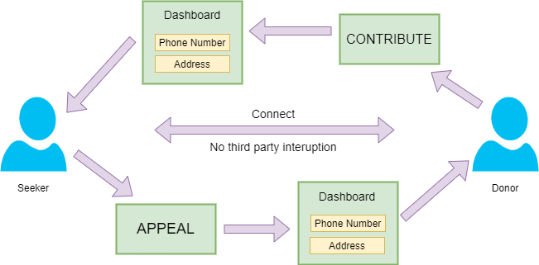

TECHNOLOGY STACK

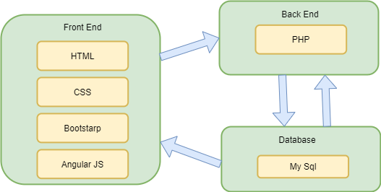

OUTPUTS

INDEX.HTML

- HEADER: -

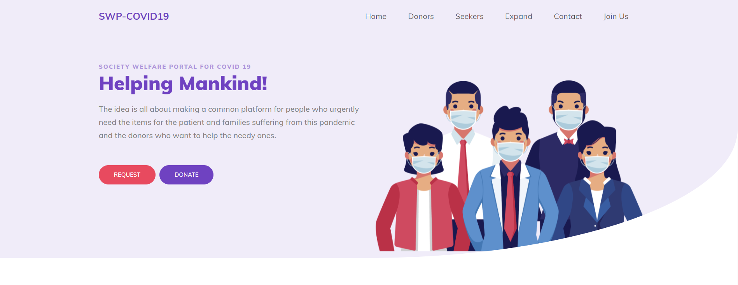

- MAIN CONTENT: -

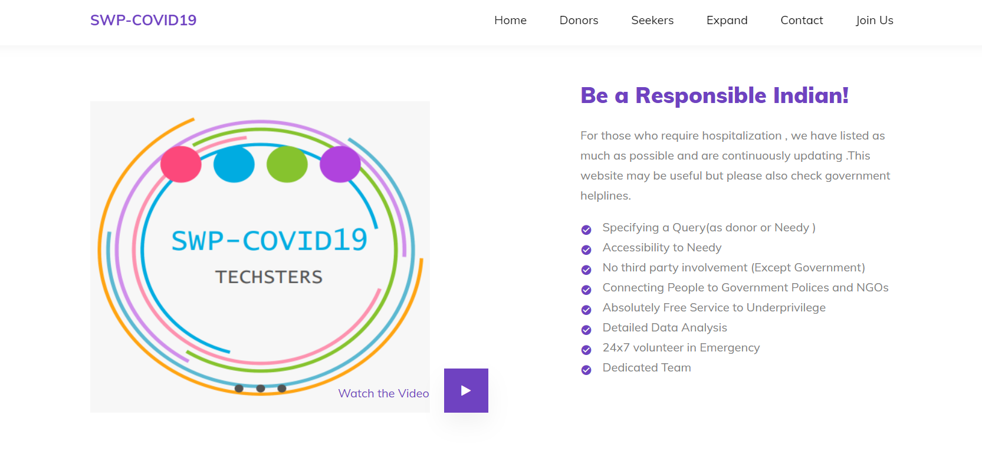

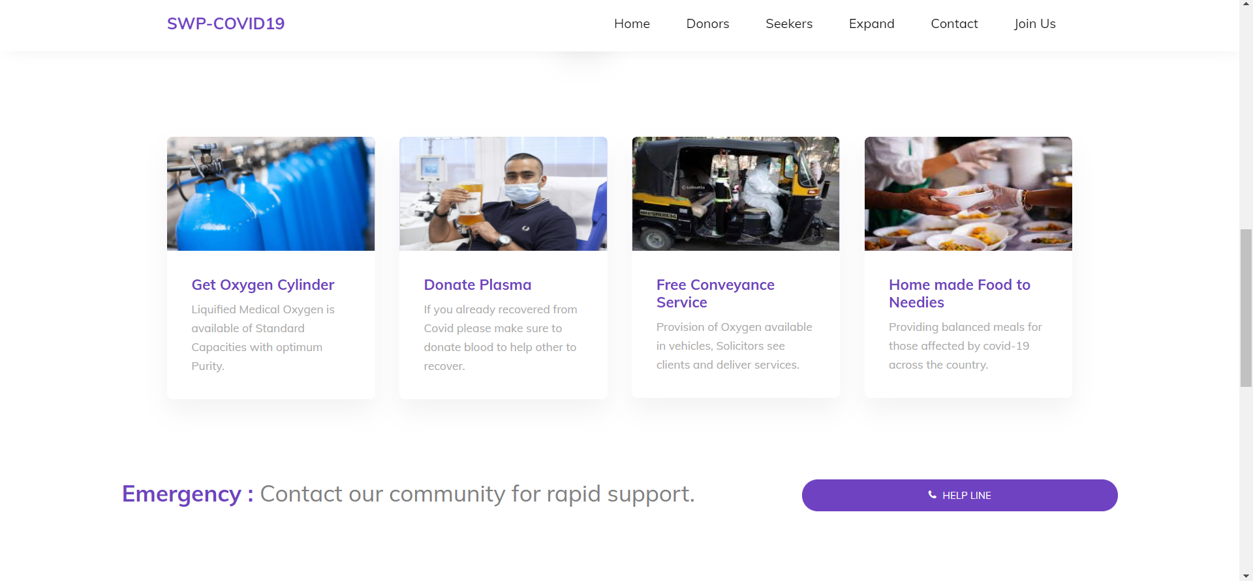

- FOOTER: -

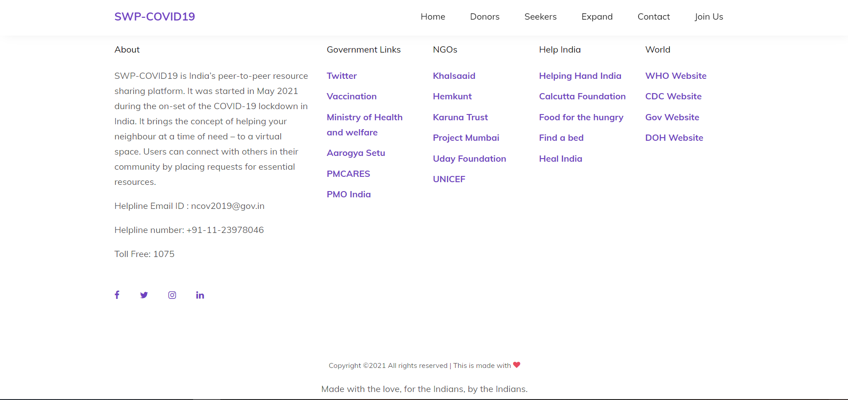

- SEARCH FOR DONERS: -

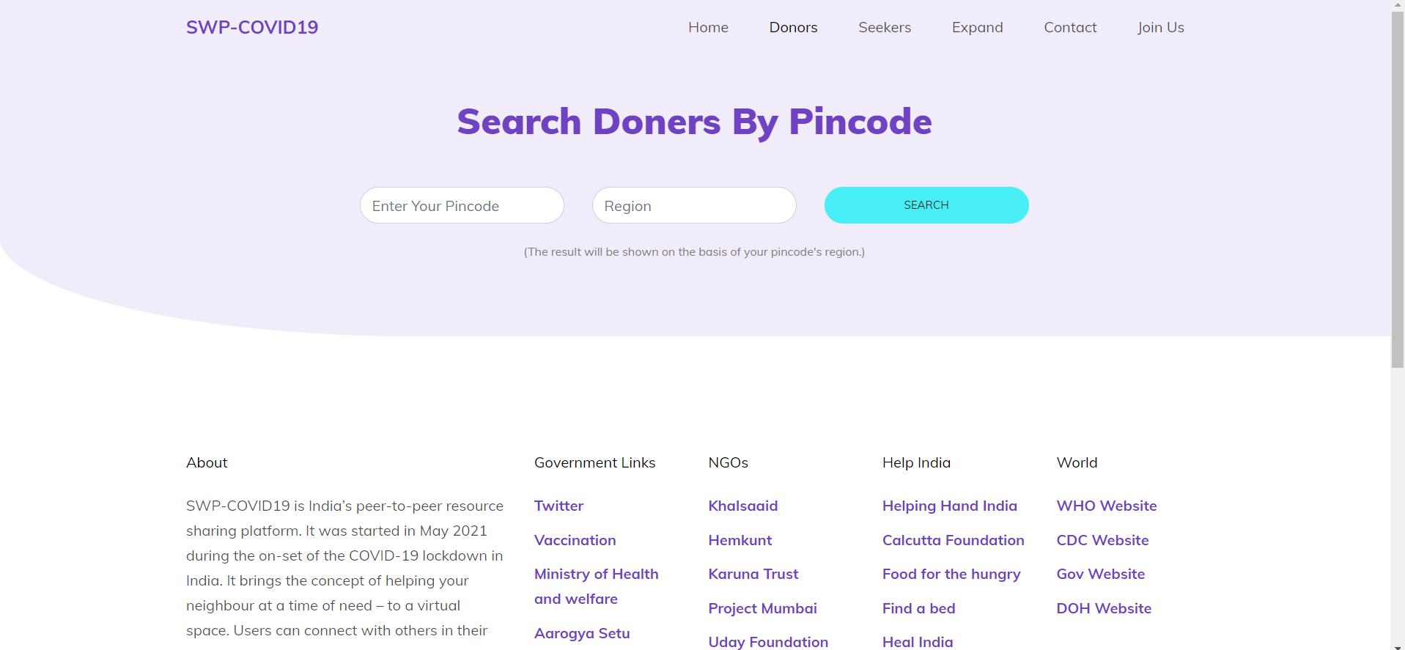

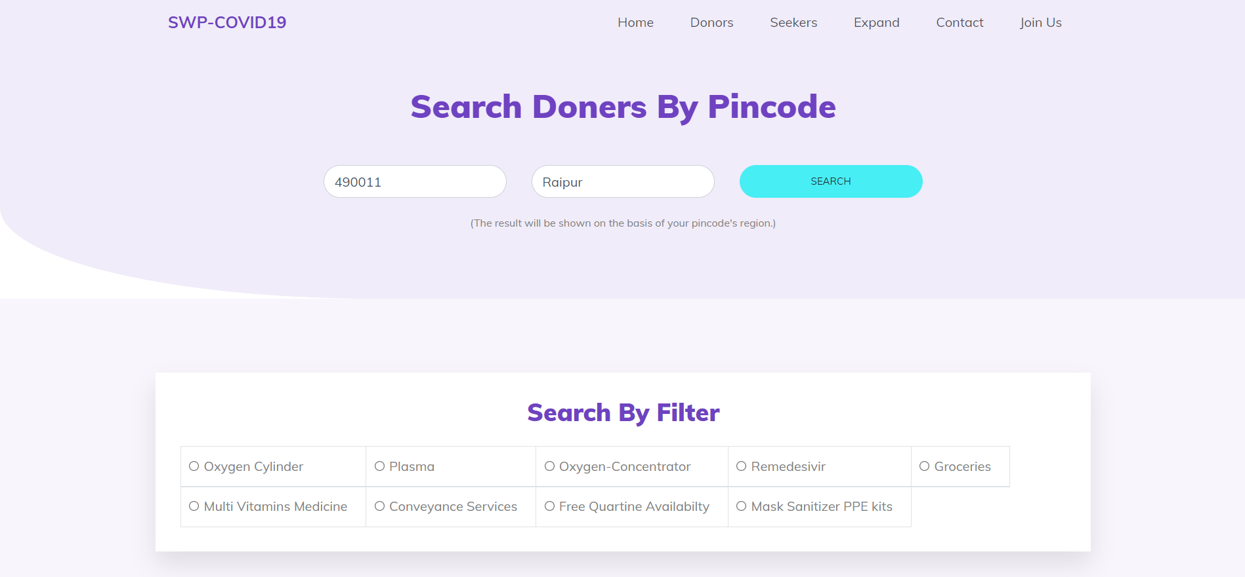

- SEARCH FOR DONER RESULTS: -

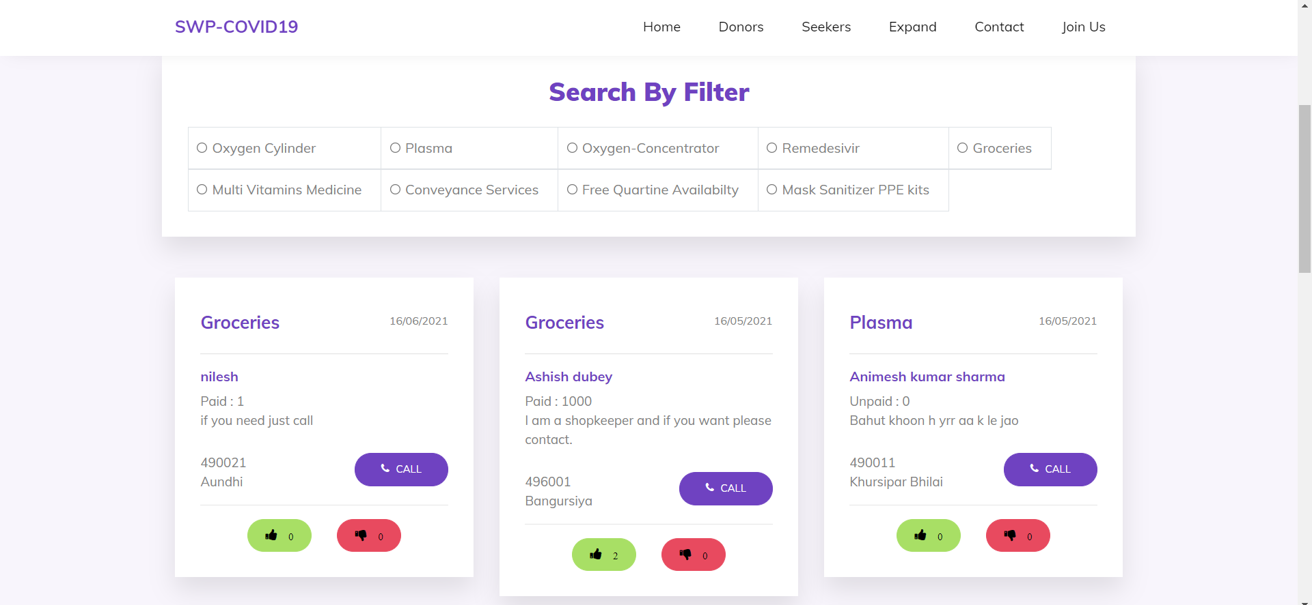

- SEARCH FOR REQUESTER/SEEKERS: -

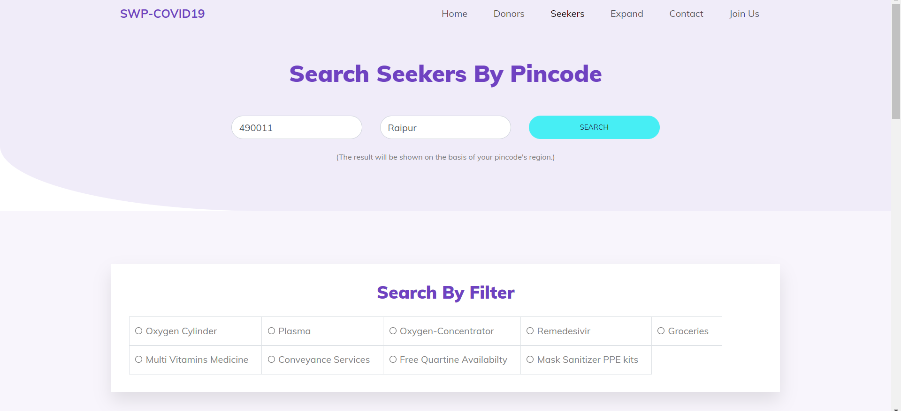

- CHOOSE YOUR IDENTITY: -

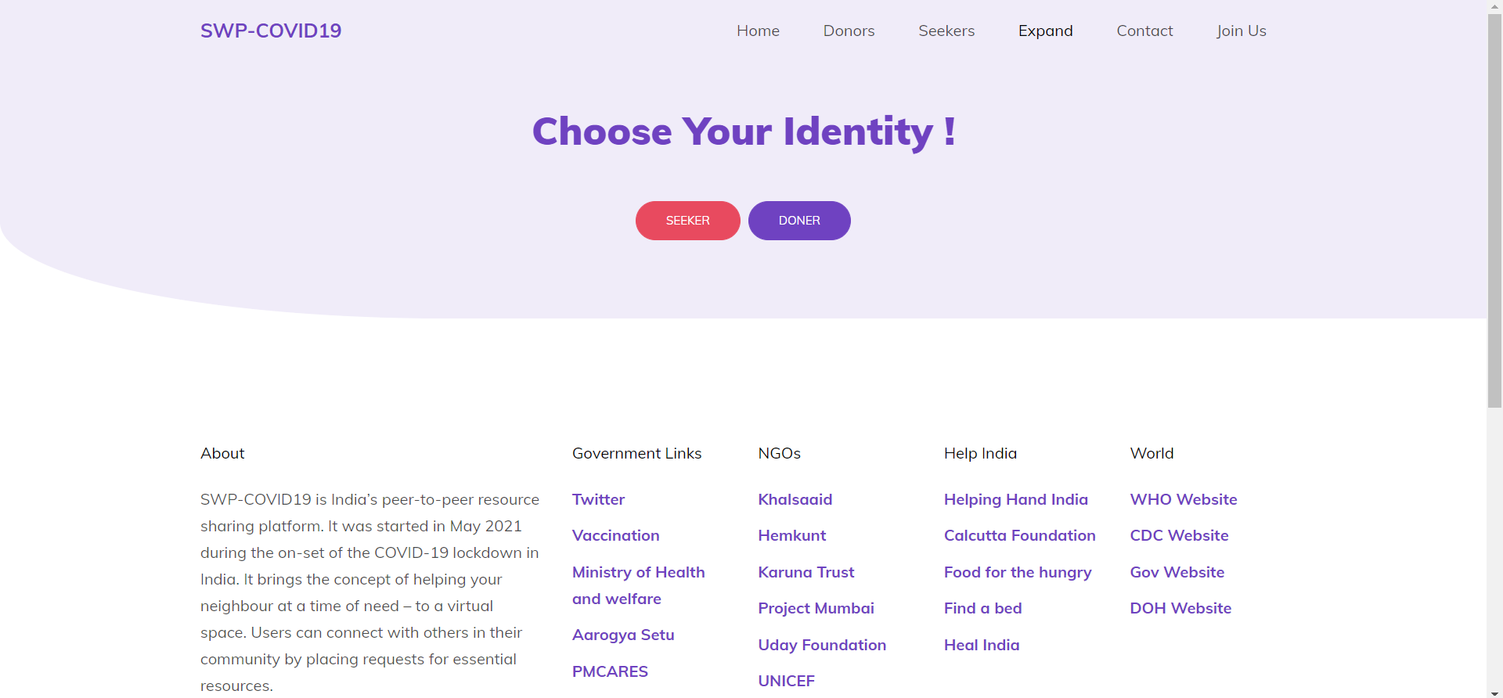

- WANT TO DONATE (DONER FORM):-

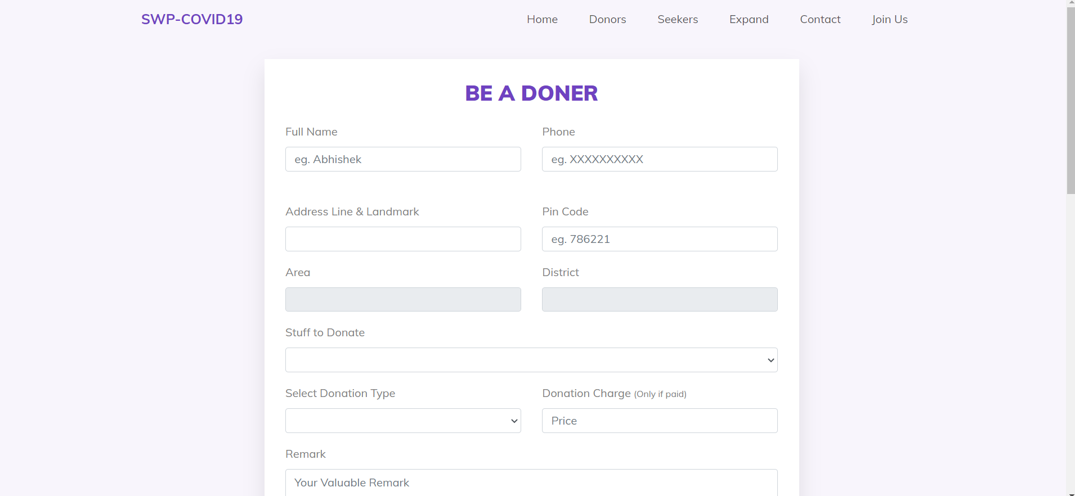

- YOU NEEED HELP (REQUESTER FORM) :-

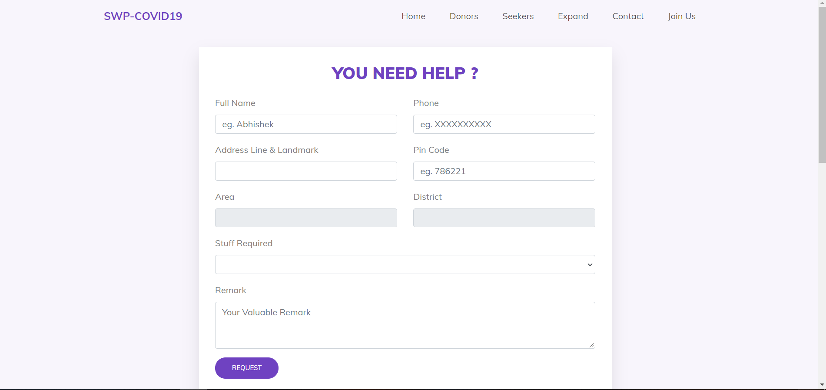

- CONTACT US PAGE: -

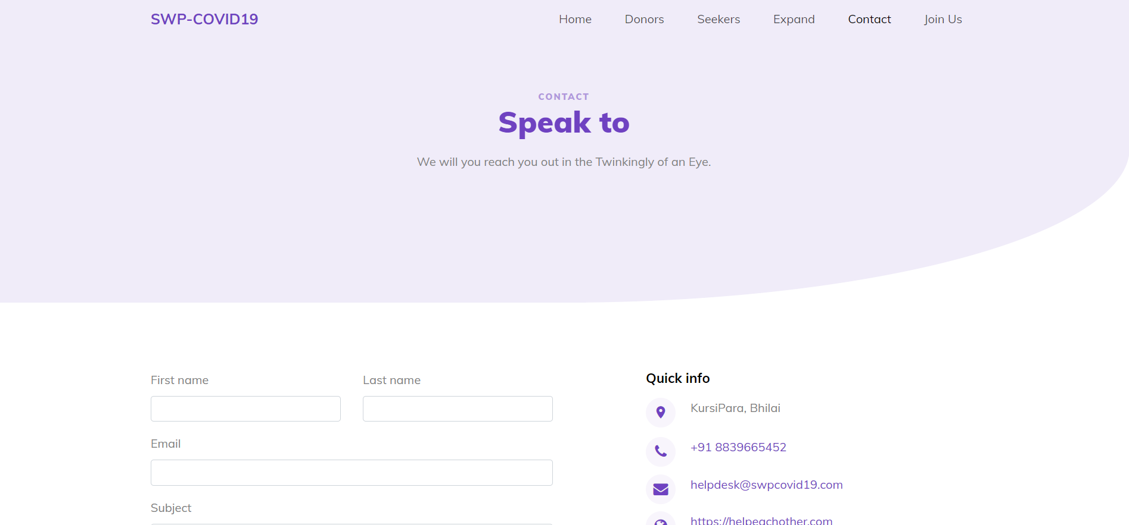

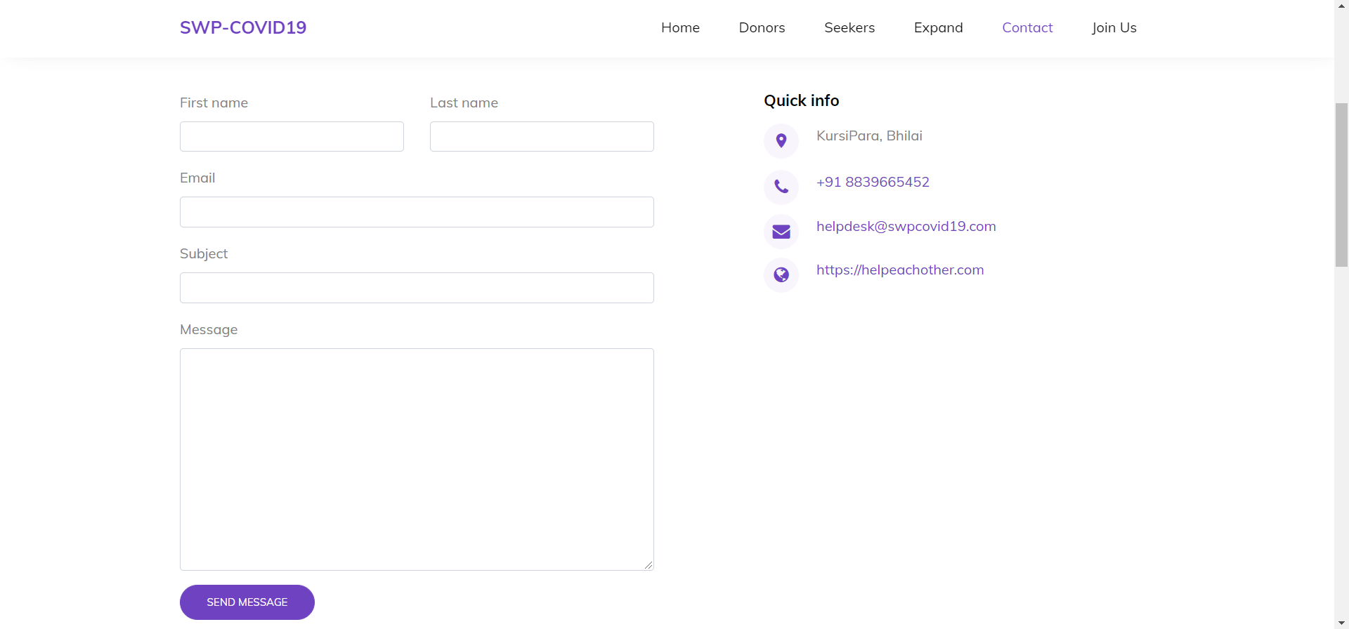

- TEAM MEMBER: -

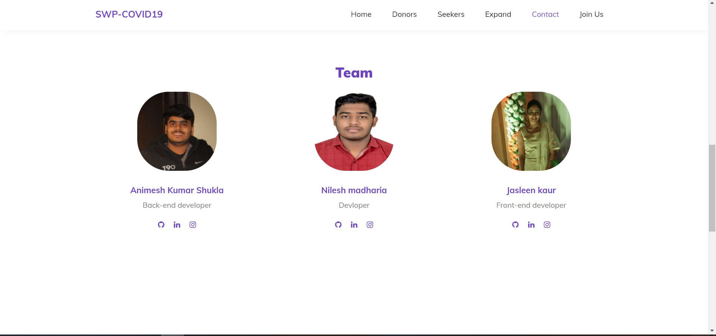

- JOIN US PAGE:-

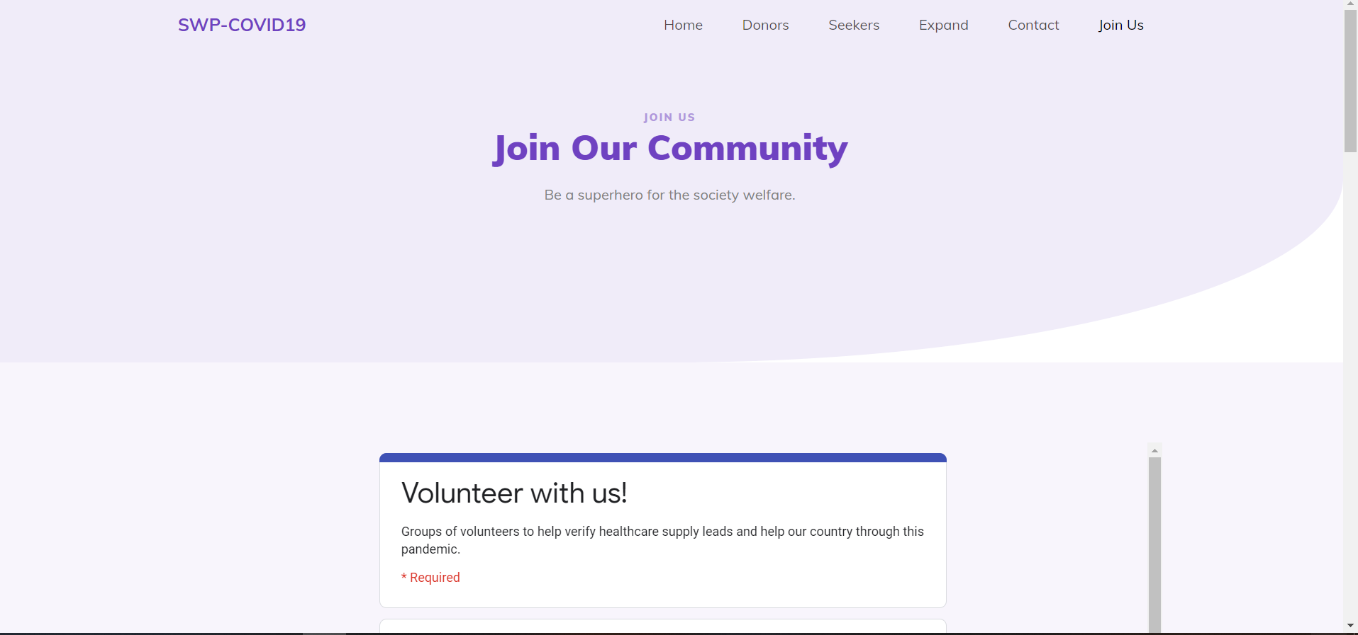

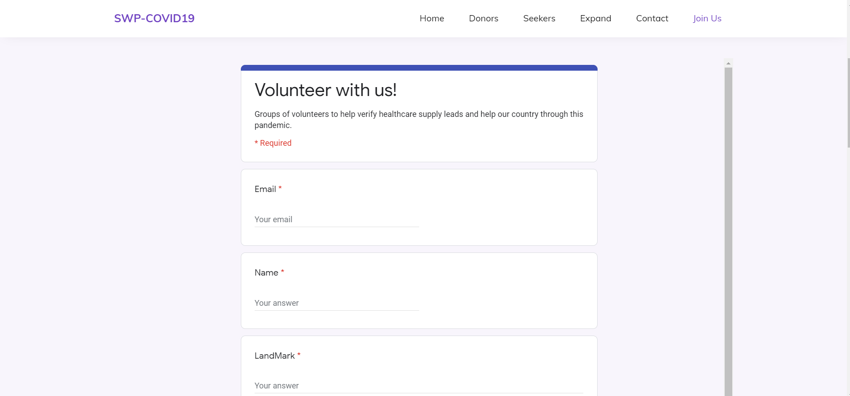

- DATABASE TABLES LIST: -

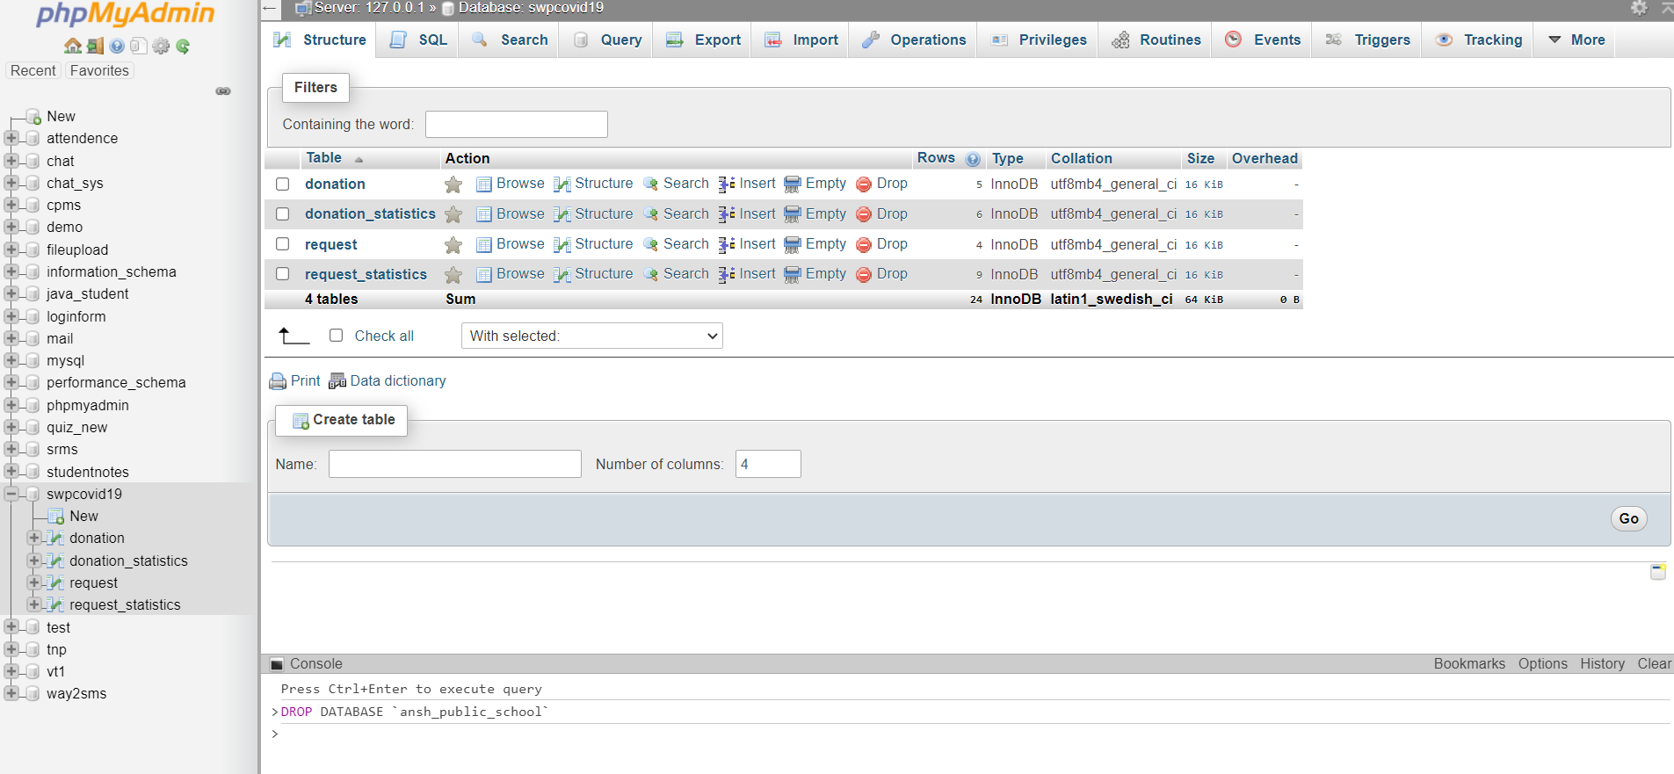

- DONATION TABLE: -

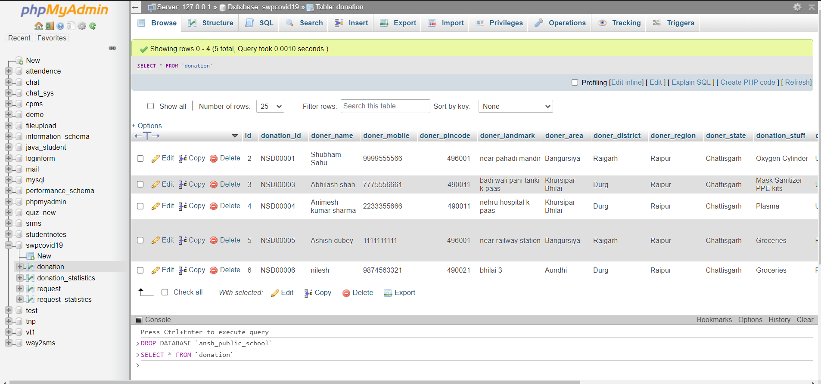

- REQUEST TABLE: -

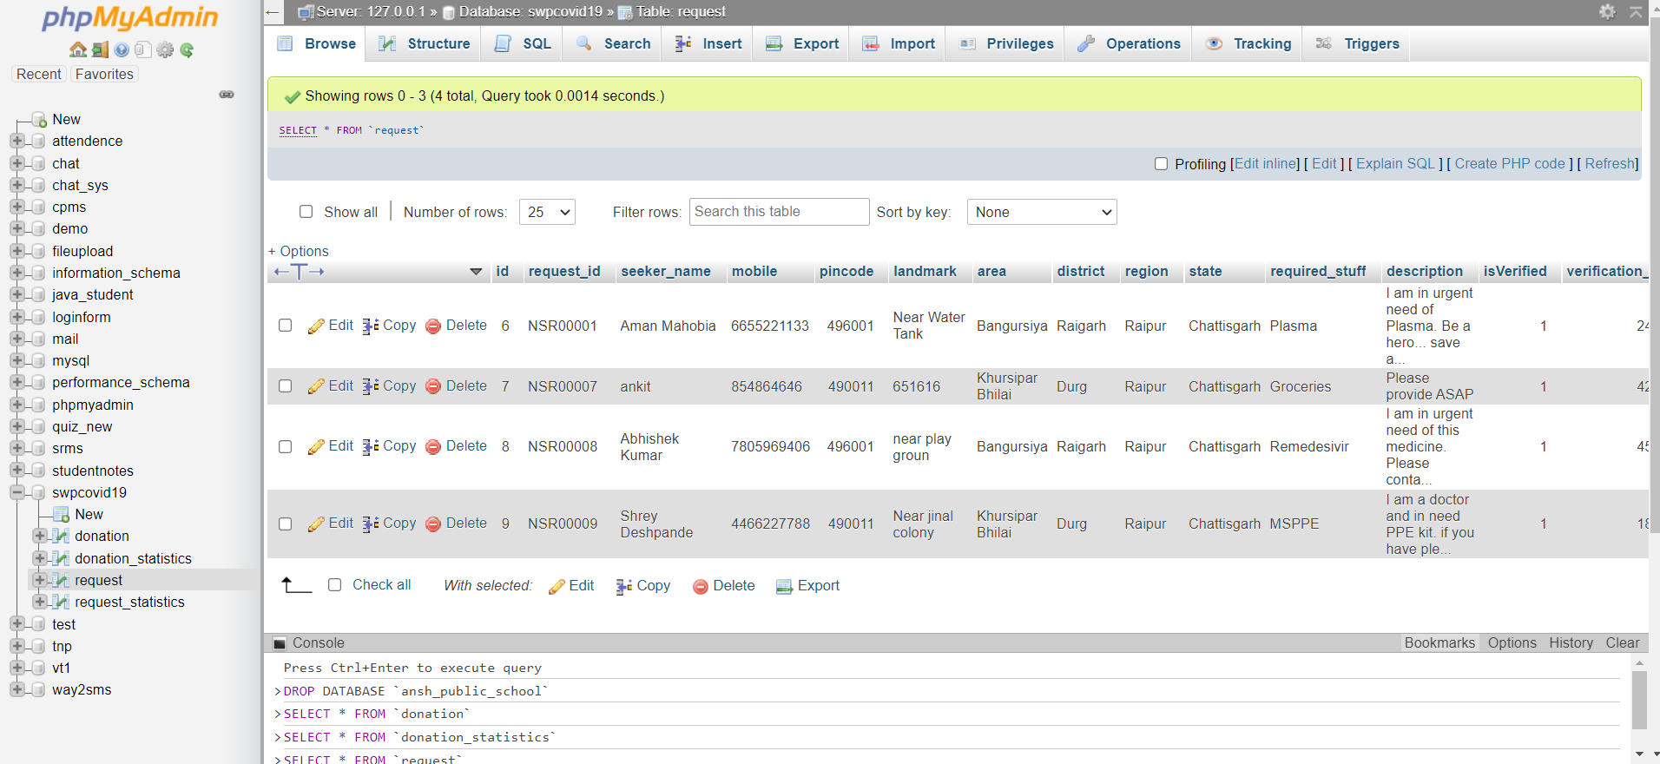

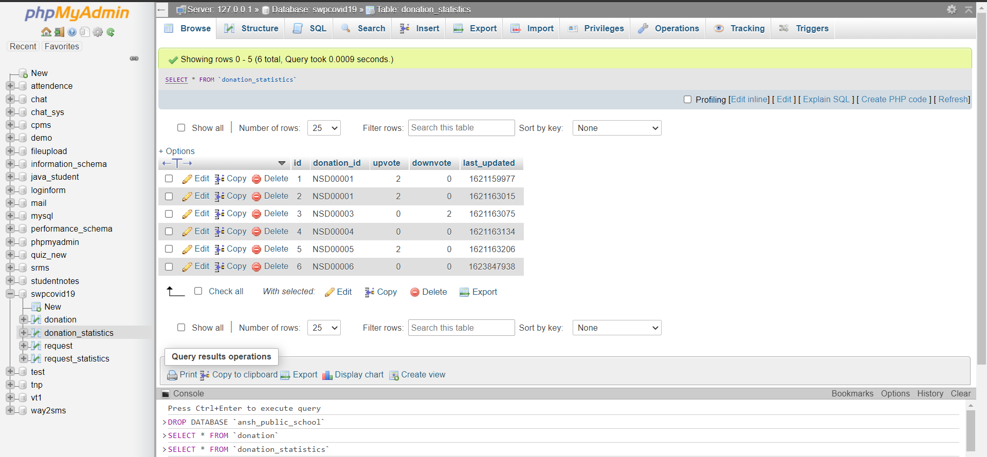

- MODEL VIEW CONTROLLER: -

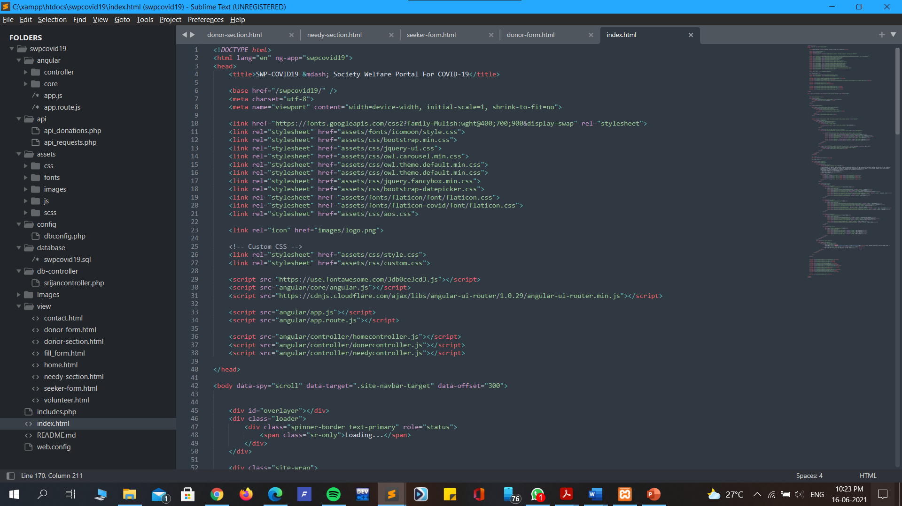

- CODE SNIPPET: -

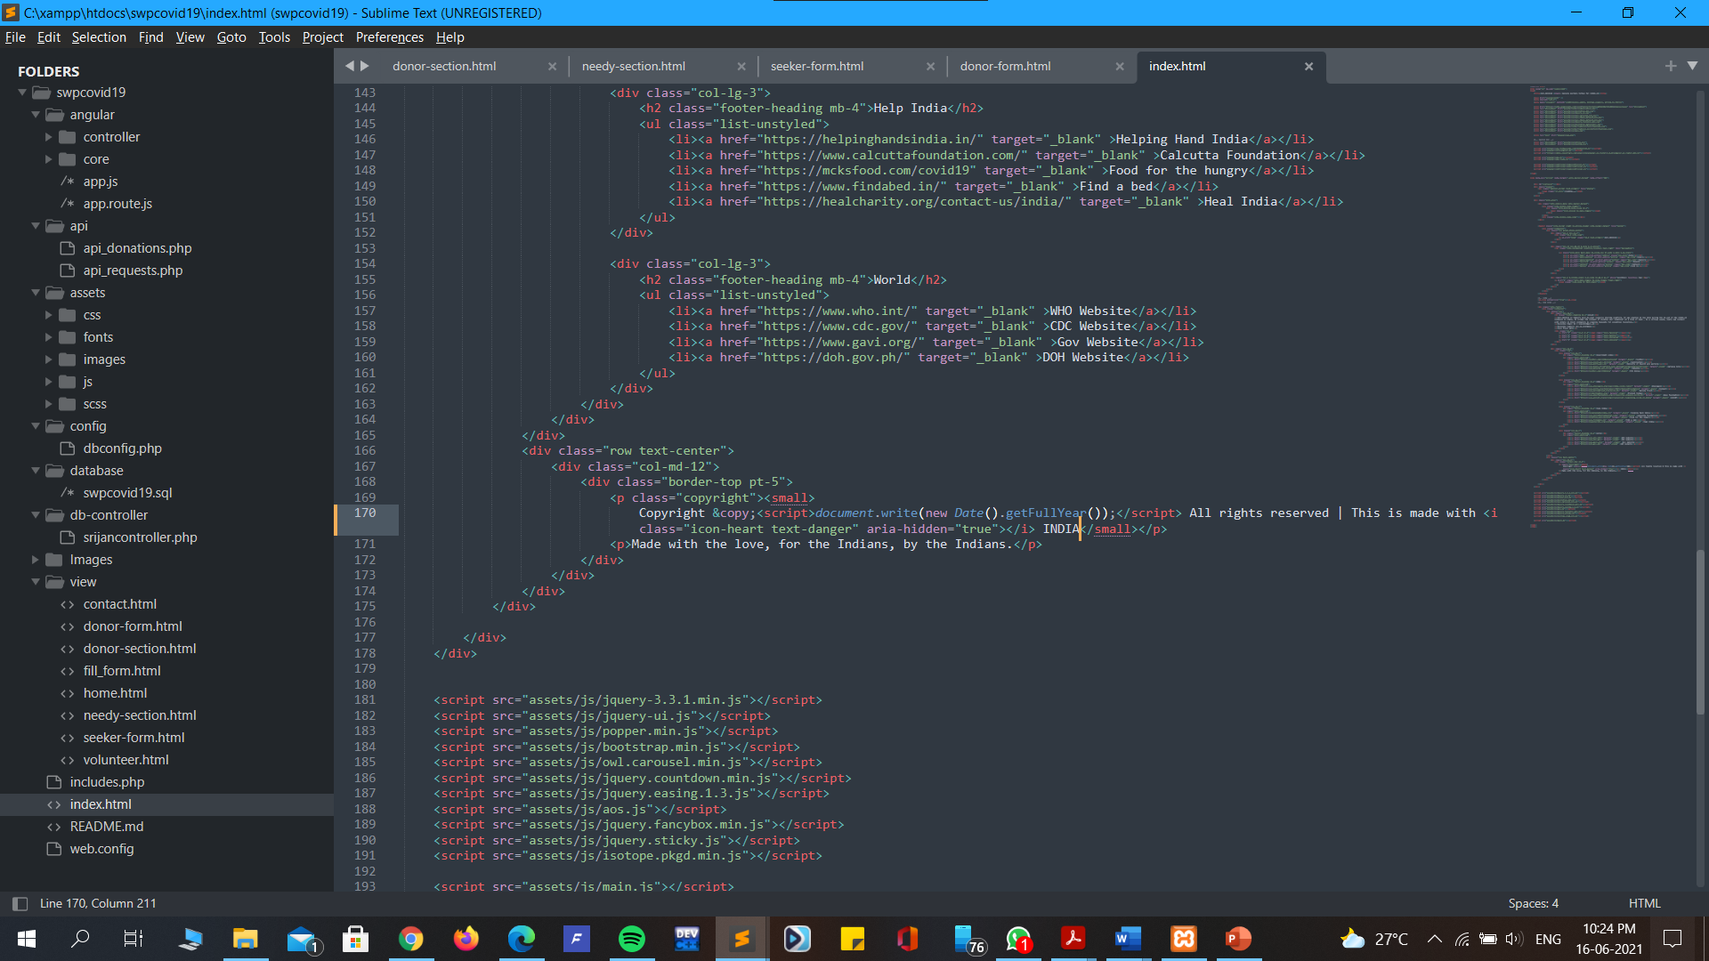

CONCLUSION

Thus, the SOCIETY WELFARE PORTAL COVID-19 has created a unique networking space to connect community ‘superheroes’ with opportunities to make a difference.
The portal has helped the users to connect with others in their community by placing requests for essential resources.

Beyond essential resources, the platform has also aimed to help people build each other by giving users a space to list services they would like to provide to their community.

From volunteering to supporting local establishments, there are a variety of opportunities
provided through this portal to help those in need during this difficult time.

Future Scope

- Navigation using Google Map APIs.
- OTP Verification system.
- Easy and convenient to use.
- Chat Bot for advisories.
- Tracking Realization of Requisites.

BIBLIOGRAPHY

Websites/References

- http://www.w3schools.com
- www.wikipedia.com
- www.geeksforgeeks.com
- Introduction · Bootstrap (getbootstrap.com)

Books

- Learning PHP, MySQL, and AngularJs
- PHP & MySQL Book by Laura Thomson and Luke Welling
- Dani Krossing Tutorials
- HTML & CSS, and JavaScript & jQuery book by Jon Duckett

